**Project 3: Google Play Store Apps**

**Description:**

Analyze Dataset to understand the relation between App Ratings based on App Type and Category and also discover which app has the maximum number of reviews using EDA & Data Visualization.

We will be using the following dataset from Kaggle which contains different play store apps information and has 10.8k rows with 13 columns.

**Dataset:** [Google Play Store Apps | Kaggle](https://www.kaggle.com/datasets/lava18/google-play-store-apps)

**Dataset Link:** <https://www.kaggle.com/datasets/lava18/google-play-store-apps>

**Questions to be answered:**

1. Which App category has the highest average rating?
2. Which App has the maximum number of Reviews?
3. What is the Average Rating for Free and Paid Apps?

**Team Members:**

1. Tanya Qader
2. Jon Argosino
3. Muhammad Hassan

**Tasks:**

1. Project Proposal Document (Tanya)
2. Exploration and cleanup
   1. Jupyter notebook (Hassan, Tanya, Jon)
3. Analysis (SQL, HTML, Javascript, Flask API)
   1. SQL (Jon, Tanya, Hassan)
   2. HTML (Tanya, Hassan)
   3. JavaScript (Hassan)
   4. Flask API (python) (Jon)
4. README.md file (Tanya)

## Maximum Reviews Per Category

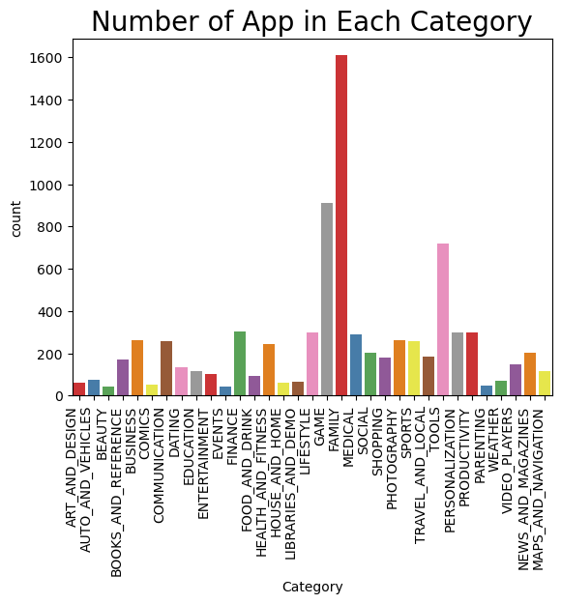

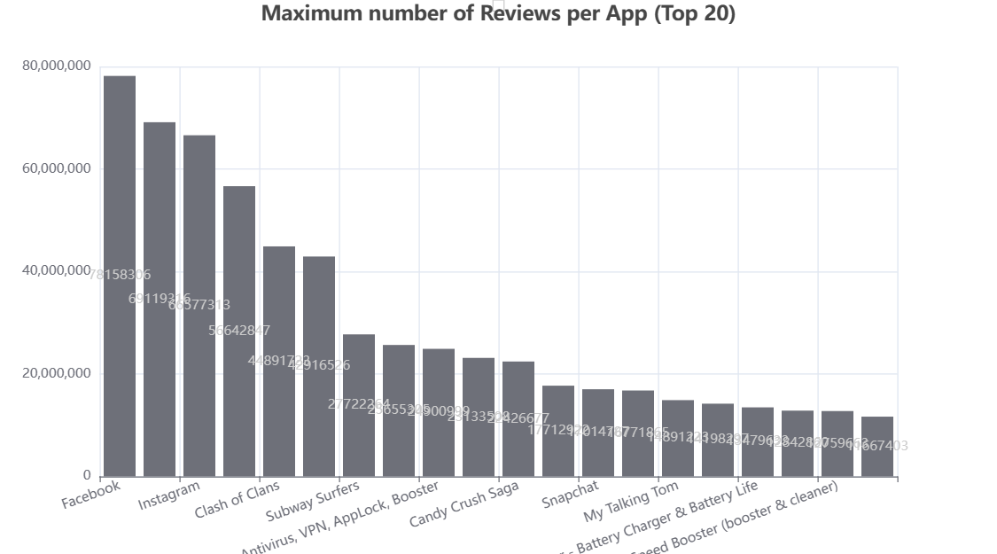

Family category has the highest number of app appearances followed by Game and Tool. We can also see the apps such as Facebook/Instagram, Clash of Clans/Subway surfers and Antivirus/Battery Life has the maximum number of reviews which falls under the same categories as well. We can conclude that maximum numbers of apps also has the maximum number of reviews as well.

## Average Rating Per App Type

There are two types of Apps available on Google play store, Free and Paid Apps. We analyzed that the 93% of Apps are Free while the remaining only 7% of the Apps are paid. Despite a huge gap between the number of Apps we have almost equal average rating for both. The average rating for Free App is 4.1 (49.45%) and for Paid App is 4.2 (50.55%). Total Number of 8719 free apps and 647 Paid Apps.

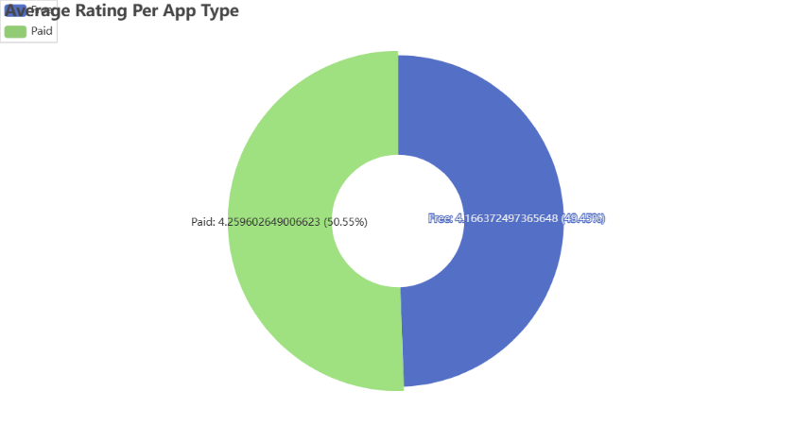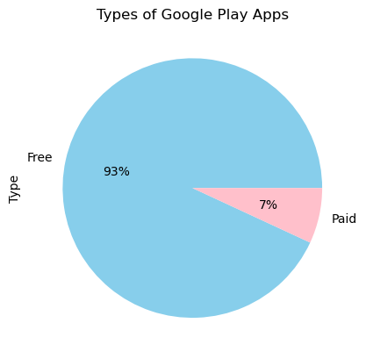

## Average Rating Per Category